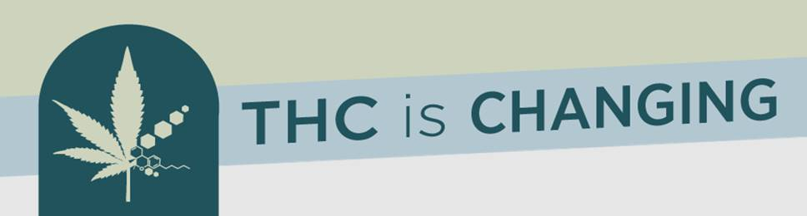

Media Talking Points:

* **Campaign Purpose**: Educate youth influencers that THC is Changing. This campaign is meant to encourage folks to “know the risks” and “talk to kids about THC use.”
* **Campaign Audience**: Influencers of Youth (coaches, teachers, parents/guardians)
* **Who**: In response to growing concerns about youth use and availability of THC, Marshfield Clinic Health System’s Northwoods Coalition formed an ad-hoc workgroup derived from the Northwoods Coalition Advisory Board to tackle the issue.
* **Why?** 
  + Tetrahydrocannabinol or THC is the chemical in the cannabis plant that is responsible for psychoactive qualities when consumed.
  + A loophole in the 2018 Farm Bill allows the sale of products containing a certain level of THC in Wisconsin.
  + Youth are being targeted to try new THC-infused products.
  + These products can be purchased by anyone, including youth, in most Wisconsin counties.
  + These products are not regulated by the Food and Drug Administration (FDA).
* For more information: Materials will be uploaded to [www.northwoodscoalition.org](http://www.northwoodscoalition.org) on Monday, April 24th.

