Underage Drinking Prevention in Wisconsin

Why It Matters and Why Prevention Works

Is underage drinking really a problem anymore?
Yes. While progress has been made, the issue remains significant.
- About 26.2% of Wisconsin youth (ages 12–17) reported drinking in the past month.
- Some estimates show over 1 in 5 youth (ages 12–20) use alcohol, with high rates of binge drinking.
- Wisconsin continues to have higher youth drinking rates than the national average.
Bottom line: The problem is smaller than it once was but still affects thousands of youth across our communities.

Kids are going to drink anyway, so why invest in prevention?
Prevention works and reduces harm.
- Youth drinking has declined over the past decade, in part due to prevention strategies.
- Evidence-based approaches like compliance checks and community policies reduce youth access and consumption.
- Early prevention helps delay first use, which is critical because youth who start drinking early are more likely to develop alcohol dependence later.4
Bottom line: Prevention doesn’t eliminate risk, but it significantly reduces it.

It’s just a phase, it’s not that harmful, right?
Underage drinking has serious, real-world consequences. 4
- Affects brain development, memory, and decision-making.
- Linked to:
  - Motor vehicle crashes
  - Injuries and alcohol poisoning
  - Violence and suicide
- Associated with poor academic performance and risky behaviors.
Bottom line: The impacts go beyond “a phase”, they can have lasting effects on health, safety, and success.

Why focus on youth?
Youth are uniquely vulnerable.
- The adolescent brain is still developing, making alcohol more harmful than in adults.
- 90% of alcohol consumed by youth is binge drinking, increasing risk of harm.2
- Early alcohol use increases lifetime risk of addiction and health problems.
Bottom line: Prevention protects developing brains and reduces long-term public health costs.

Why is this so important for Wisconsin youth?
High availability and cultural norms make alcohol more accessible to youth.3
- Communities play a key role in shaping7:
  - Access to alcohol
  - Expectations and norms
  - Youth opportunities and supports
Bottom line: Local action directly influences youth outcomes.

What can prevention look like?
Effective strategies include:
- Enforcing the minimum legal drinking age4
- Conducting retail compliance checks
- Reducing youth access in homes and social settings
- Promoting healthy, engaging alternatives (sports, arts, mentoring)3
Bottom line: Prevention works by helping youth make healthy choices and delay or avoid drinking altogether.

Key Message
Underage drinking is harmful to youth. But it is preventable, and prevention works.
Communities that invest in prevention see:

Lower youth alcohol use
Fewer injuries and deaths
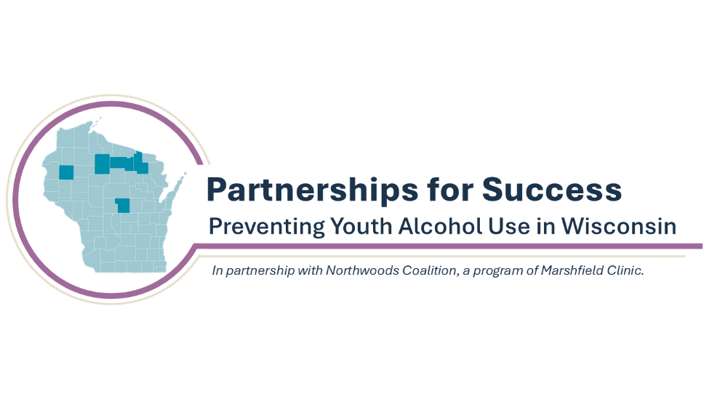
Stronger, healthier future generations

This Strategic Prevention Framework - Partnerships for Success grant is managed under the direction of Marshfield Clinic, funded by SAMHSA (H79SP083958).

Wisconsin Department of Health Services – Alcohol: Youth Use Dashboard: https://www.dhs.wisconsin.gov/alcohol/youth-use.htm
CDC – Underage Drinking Fact Sheet: https://www.cdc.gov/alcohol/underage-drinking/index.html
Medical College of Wisconsin – Alcohol Policy Project: https://www.mcw.edu
Frontiers in Neuroscience (2022). Adolescent Brain Development and Alcohol Effects frontiersin.org
National research on compliance checks and youth access reduction projectextramile.org
Nature Mental Health (2025). Adolescent Alcohol Use and Long-Term Risk nature.com
National Alcohol Beverage Control Association. Reducing Youth Access to Alcohol nabca.org

